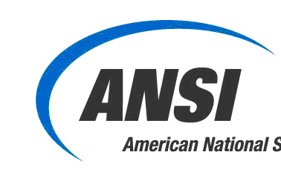
U.S. Technical Advisory Group (US TAG) to ISO/TC 338
Menstrual products

New US TAG Member Application

(Please return the completed form to the US TAG Administrator: rhawthorne@ansi.org.)

In order to qualify as a member of the US TAG, you must be a U.S. National Interested Party, which is defined as:

One of the following entities directly and materially affected by the relevant standards activity:
- a corporation or an organization domiciled in the U.S.; or
- a U.S. branch office of a foreign company registered or authorized to do business in one or more U.S.
- U.S. federal, state or local government entity; or
- a U.S. citizen or permanent resident.

I confirm that I qualify as a U.S. National Interested Party: |  | Yes, I qualify  No, I do not qualify
US TAG Members are expected to participate actively by fulfilling attendance, voting, correspondence, and other obligations.

I confirm that I am willing to participate actively on the US TAG: |  | Yes, I intend to participate actively.  No, please consider me as an Observing member.*
*Observers shall be advised of the U.S. TAG activities, may attend meetings, and may submit comments for consideration, but shall not vote.

Please provide the following contact information:

Salutation (Dr., Ms., etc.):

First and Last name:

Telephone Number:

Email address:

Please indicate your membership type: |  | I will be representing a company, organization or government agency.*  I will be an individual member representing myself.
*For those representing a company, organization or government agency, please provide the following information:

Company/Org/Agency name:

Address/website:

Alternate contact (optional):

Please indicate your primary Interest Category:  Producer:  A member, or a member who represents an organization that produces or sells materials, products, systems or services covered in the scope of the documents developed by the committee.  User:  A member, or a member who represents an organization that uses materials, products, systems or services covered in the scope of the documents developed by the committee.  Government:  International and regional treaty organizations and agencies; national government and local government departments and agencies, and all bodies that have a legally recognized regulatory function.  General interest:  Those whose business or other interests are not covered by another discretely defined interest category  Note: If you would like to suggest additional stakeholder categories we can review these periodically as to what makes the most sense for the U.S. TAG. |  | Producer  User  Government  General interest
Please provide any additional information or statements for the US TAG members to consider while reviewing your application for membership:

Please return the completed form to the US TAG Administrator: rhawthorne@ansi.org. |  | Date:

